Living *Laudato Si’*: Your Parish and Your Planet:

Zoom Retreats, 3rd-6th September *or* 15th-18th October 2021

*Boarbank Hall, Cumbria, and The Ecological Conversion Group*

**WHY?** Faith is the place to start.

**WHAT?** Understanding is the place to start.

**HOW?** Sharing experience is the place to start.

**WHEN?** Now is the place to start.

**WHERE?** Your parish is the place to start.

**WHO?** Are YOU the place to start?

**What will happen?** A long weekend of talks and discussions on zoom, and practical activities, on living the message of *Laudato Si’* in and through your parish.

**Who is it for?** Any interested parishioner (including clergy!) is most welcome to join us. The weekend is aimed especially at people with parish responsibilities or who are part of or want to start a relevant parish group.

**Times** Sessions will be on Friday evening, Saturday morning, late afternoon and evening, Sunday late afternoon and evening night and Monday evening (leaving people free during the day on Monday).

**Speakers** include:

***Cardinal Vincent Nicolls and Bishop Paul Swarbrick***, whowill begin and end the September weekend with prayer and reflection. ***Members of the Dioceses of Westminster and Lancaster are especially encouraged to attend this weekend.***

***Bishop Alan Williams and Bishop Mark O’Toole***, whowill begin and end the October weekend with prayer and reflection. ***Members of the Dioceses of Brentwood and Plymouth are especially encouraged to attend this weekend.***

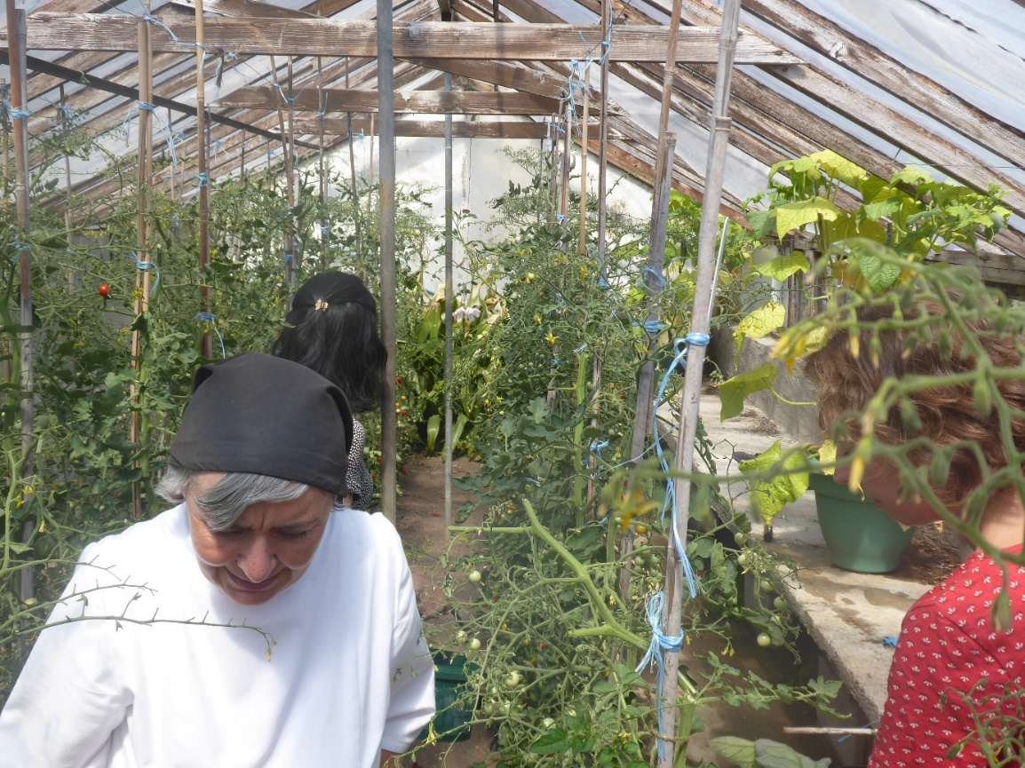

***Trish Sandbach***, who worked in Oxfam Education for many years and led to St Benedict’s, Garforth, in the Leeds diocese, to winning a *Live*Simply award. She is also an assessor for the *Live*Simply award (see https://cafod.org.uk/Campaign/Livesimply-award).

***John Paul de Quay***, a founder member of the Ecological Conversion Group and *The Journey to 2030* (see https://journeyto2030.org/).

***Sr Margaret Atkins***, an Augustinian Canoness at Boarbank Hall in Cumbria, a teacher of philosophy and theology, with a lifelong interest in the natural world, and author of *Catholics and Our Common Home: Caring for the Planet in a Time of Crisis* (CTS).

Panel discussions with experts, for sharing advice on practical projects.

**Cost - voluntary donations gratefully accepted**, but there will be no fee for the weekend.

**To apply**, simply email Sr Margaret Atkins on [margaret@boarbankhall.org.uk](mailto:margaret@boarbankhall.org.uk).

